1-3 Assignment: Installation, MongoDB Image, and Testing

Module 1

Candace Ralston

2023

Main Docker screen:

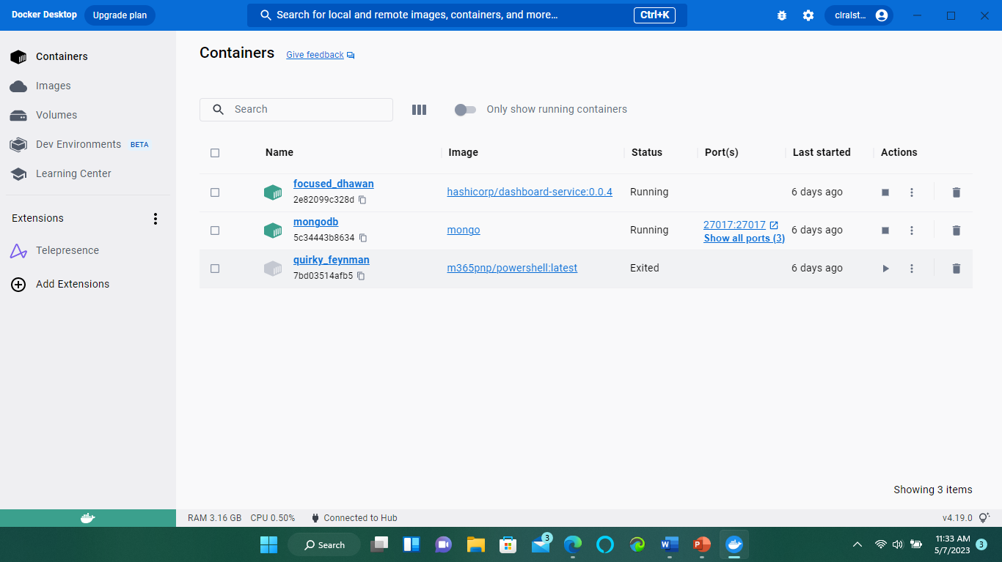

MongoDB screen:

